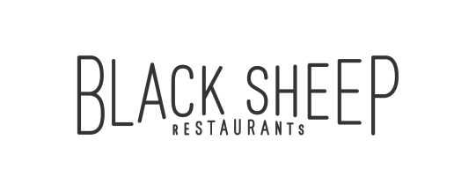

Black Sheep Restaurants is a Hong Kong-based hospitality group that specialises in developing niche, thought-provoking restaurant concepts that add to the existing culinary dialogue.

Whether recreating popular international concepts for the Hong Kong market or developing standalone restaurants, Black Sheep Restaurants curates distinct dining experiences that tell a story about a particular time, place, culture or cuisine while celebrating the bounty of premium ingredients available both locally and from abroad. The group currently boasts a portfolio of thirteen restaurants and bars, including Chôm Chôm, Motorino (Soho & Wan Chai), La Vache!, Ho Lee Fook, Carbone, Burger Circus, Stazione Novella, Le Garçon Saigon, BELON, Maison Libanaise, Buenos Aires Polo Club and Soul Food.

**Captain**

**Main Responsibilities**

* Lead, supervisor and train servers to deliver high quality customer service
* Monitor and oversee food quality, hygiene and work safety issues
* Assist in other ad hoc projects as assigned

**Requirements**

* 5 years fine dining or hotel experience is preferable
* Easy going, opened minded, sincere and pleasant attitude
* Fluent in spoken English with strong writing skills

**Benefits**

* Competitive salary
* Quarterly discretional bonus
* Staff discount
* Education sponsorship program
* Related training provided

Interested candidates please send their resume with **CURRENT and EXPECTED** salary to: [careers@blacksheeprestaurants.com](mailto:careers@blacksheeprestaurants.com) or contact our HR Team at 2810 0062 if you have any inquiries.

*(All personal information collected would be kept strictly confidential and for recruitment purposes only.)*